
s
Technical Notes
Understanding and implementing the methodology of the Epidemiology NLP Program Builder
February 2025
Epidemiology NLP Program Builder (EpiNLP Builder)
Contents
Overview 3
Introduction 3
Background 4
Development 4
Structure 5
Repository 5
Sub-Packages 6
Process 9
Build 10
Evaluate 12
Export 12
Annotate 12
Approximate Complexities 13
Usage 13
Developer Usage 13
Graphical User Interface 18
Support 18
Appendices 19
Appendix 1: Dependencies 19
Appendix 2: NLP Parameter Roles/Formats 20
Appendix 3: Exceptions 22
Appendix 4: Vectorisation Techniques 24
Bibliography 25

Overview

Introduction
The Australian Capital Territory (ACT) Health Epidemiology Natural Language Processing Program Builder (EpiNLP Builder) is an end-to-end software package which facilitates the automated classification of free text data. The following is a series of technical notes detailing the structure, process, and usage of the builder.
NLP is a branch of artificial intelligence which converts natural written English, also called free text, into a computer processable form. ‘Natural language processing combines computational linguistics and machine learning models to enable computers to recognise, understand and generate text’¹. These are valuable capabilities for computers to have in the ACT Health Directorate. There is a vast expanse of free text data stored in the ACT Health Directorate information systems. NLP will enable fast, sophisticated, and large-scale analysis of this free text, while ensuring patient confidentiality. This will provide access to previously unattainable information to guide the development of policies in the ACT.
EpiNLP Builder produces programs which can extract meaning from free text. The output programs conduct binary classification of free text. Taking an input of a list of pieces of text, these programs produce a list of corresponding classifications into one of two categories. This is implemented by taking an existing .csv or .xlsx file containing a column whose entries are free text. The program builder adds a column to this file whose entries are the corresponding classification of the text in each row. This process demonstrates high efficiency, capable of classifying hundreds of thousands of text pieces within minutes.
These programs utilise machine learning to classify immense amounts of information. To construct an NLP program, the builder requires manually annotated data to learn from. EpiNLP Builder requires a .csv or .xlsx file with a column whose entries are pieces of free text and a column whose entries are 0 or 1, corresponding to the classification of each piece of text. The 0s and 1s in the classification column should be entered by someone with relevant expertise who manually annotates each piece of text in the file. This file should contain only a subset of free text pieces selected from the larger set of texts to be classified. The manually annotated data is then divided into training and testing datasets. EpiNLP Builder will then create an NLP program to match the manual annotation. This process can be repeated as new data becomes available.
EpiNLP Builder enables the user to customise the process by which the output programs classify text. Through a Graphical User Interface (GUI) or Python software package, the user can configure EpiNLP Builder by specifying a choice of annotated data set, demographics, data composition, linguistic analysis techniques, and machine learning algorithm. Using these specifications, EpiNLP Builder produces an NLP program and an evaluation of that program. Different combinations of inputs will result in output programs with various levels of performance. The evaluation details the precision and recall² of the program based on the testing data.

Background
EpiNLP Builder was initially created to provide a specific, sensitive, and efficient method to quantify Emergency Department presentations related to suicide or self-harm. The ACT Office for Mental Health and Wellbeing had conducted an analysis of Emergency Department records from the ACT Emergency Department Information System (EDIS) dated between July 2015 and June 2022. The analysis described in this paper separately quantified Emergency Department records related to suicide or self-harm based on associated ICD-10AM clinical codes, a keyword search of triage notes and manual readings of triage notes. Using this manual annotation as a gold standard for the number of presentations related to suicide or self-harm, it was found that quantifying using ICD-10 clinical codes produced a significant undercount, while quantifying using keyword searches produced an overcount. Hence, it can be stated that using ICD-10 clinical codes lacks sensitivity, while keyword searches lack specificity, and manual readings lack efficiency.
To address this issue, a project titled ‘Natural Language Analysis in Python: The Epidemiology of Self-Harm’ was initiated. This project aimed to use manually annotated data to train a machine learning based NLP program. This program would be used to identify Emergency Department records related to suicide or self-harm based on triage notes included in the ACT ED data collection. To extend the program’s functionality, the project was expanded to include the development of an NLP program builder, EpiNLP Builder. EpiNLP Builder would receive program customisations as its input and produce an NLP program as its output. EpiNLP Builder produced programs which successfully identified records related to suicide or self-harm. As a result, the builder was expanded such that it could receive more general annotated data. This enabled the output programs to classify pieces of text based on any binary classification provided in the annotated data. EpiNLP Builder can create programs which extract a vast expanse of information from free text data. Programs could be produced to identify a variety of conditions, causes, and issues from a range of free text sources.

Development
EpiNLP Builder was initially conceived as an exploratory project offered as part of the ACT Health Research Strategy, Vacation Study Program (VSP). The VSP was undertaken by George McNamara, from November 2023 to February 2024, and was supervised by Glenn Draper and Dr Louise Freebairn, while Paul Mayers, Dr Gao Zhu, and Aidan Whitfield provided significant input. Dr Erin Walsh, from the Australian National University’s Population Health Exchange, provided academic supervision and significant expertise. This initial piece of work included a technical literature review of NLP in a health data environment and NLP tools implemented in Python. The VSP also included initial development of an NLP program which focussed on suicide and self-harm. The VSP demonstrated that the project was feasible within the ACT Health context and environment, and the project was continued through the ANU Science Coursework Internships Program, and the ACT Health Directorate, Epidemiology Section, Knowledge Translation and Health Outcomes Team. With the initial NLP program completed, work began on EpiNLP Builder. Development of EpiNLP Builder is continuing within the Knowledge Translation and Health Outcomes Team, as they prepare to release the EpiNLP Builder version 1.0.0. To enquire about the project or become involved, please email one of the following addresses:
George.mcnamara@act.gov.au or epicentre@act.gov.au

Structure
EpiNLP Builder is an object-oriented, modular software package written in Python 3.10.9. All code and documentation that supports the NLP Program Builder is stored in a GitHub repository named ‘EpiNLP Builder’ managed by George McNamara. As a modular software package, the code is organised into several sub-packages. A detailed description of the structure and contents of this repository and these sub-packages is provided below.

Repository

data
This directory contains a single file called data.md. This directory is a convenient location for storing .csv and .xlsx files containing annotated data. Files can be imported from other directories and the program is in no way limited by this directory. When running Python modules in this package directly for testing and development, it is easiest to store any data which will be imported in this directory. data.md also explains the purpose of this directory. This directory has no impact on the operation of the package and exists only for developer and user convenience.

docs
This directory contains only a single sub-directory called html. This sub-directory contains all the files which support the HTML documentation of the package. The Doxygen³ package was used to help create the contents of this sub-directory. To access the homepage of the HTML documentation directly, open html\index.html. If documentation in other formats is created in the future, it will be stored in the docs directory.

gui
This directory is a Python sub-package which implements the GUI for this package. Its structure is detailed below under ‘Sub-packages’.

model
This directory is a Python sub-package which supports the storing and demonstration of NLP Programs created by this package. Its structure is detailed below under ‘Sub-Packages’.

package
This directory is a Python sub-package which implements the NLP program building, evaluating, exporting, and annotating processes. Its structure is detailed below under ‘Sub-Packages’.

tests
This directory is a Python sub-package which implements tests for the back end of this package. Its structure is detailed below under ‘Sub-Packages’.
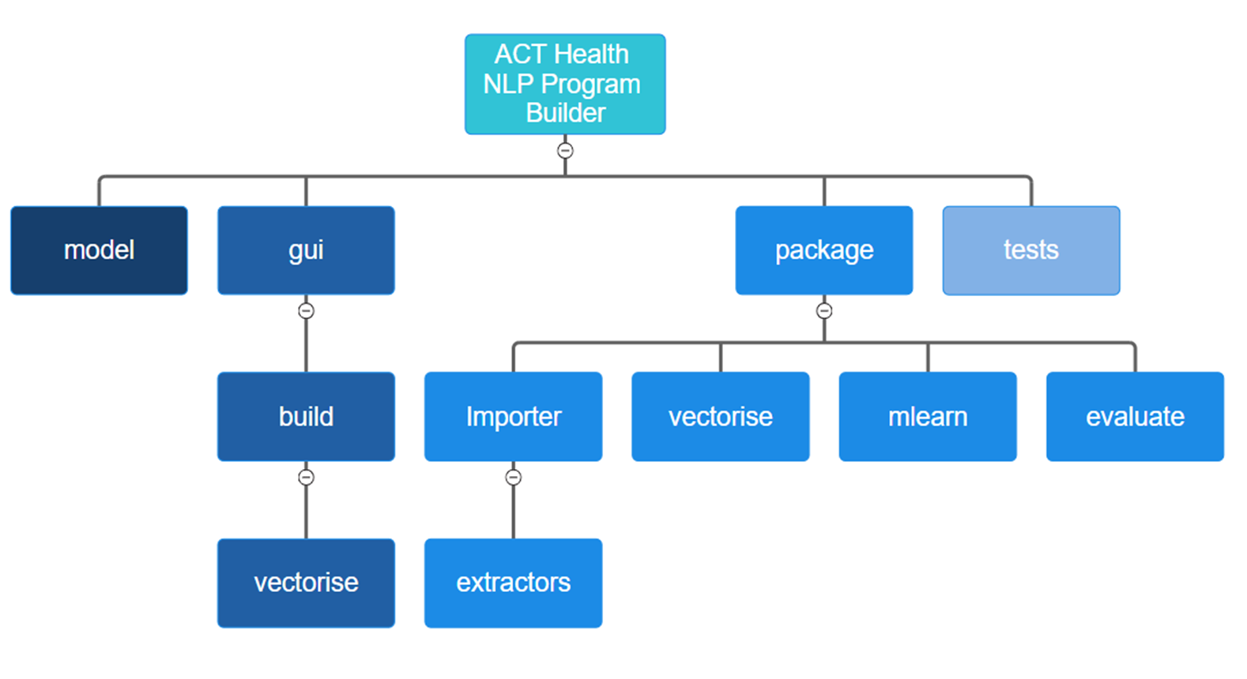
Figure 1: The structure of all packages in EpiNLP Builder ⁴.

Sub-Packages
The EpiNLP Builder package is organised into 4 sub-packages: gui, package, model, and tests. Some of these sub-packages contain their own sub-sub-packages. The structure of all packages is shown above in Figure 1. gui accepts the program customisation inputs from the user. It then passes these inputs to package where an NLP program is constructed and evaluated. package exports the program and its evaluation to model where it can be stored, demonstrated, and utilised. package also exports the evaluation to gui so that it can be displayed to the user. The full process of building an NLP program is explained in detail in the ‘Process’ section below. tests contains a suite of tests to check the functionality of package.

gui
This sub-package is the front end of EpiNLP Builder. This package creates and operates a GUI. As of version 1.0, this GUI is not complete however it will be provided in a subsequent version. Once completed, all user interactions with EpiNLP Builder can be facilitated through the GUI. The user interacts with different input fields, across multiple nested tabs to enter the customisation parameters for the building of an NLP program. gui accepts these inputs and formats them such that they can be accepted by the package’s back end, implemented in package. gui also ensures that users receive appropriate responses as they enter parameters. Once the back end has constructed, evaluated, and exported the NLP program, gui accepts the evaluation and formats it into a user-friendly display. gui also displays to the user where the program they have built is stored.

build
build is a sub-package of gui. This package creates and operates the ‘Build NLP Program’ tab in the GUI. This tab guides the user through the process to specify parameters to construct an NLP program. The ‘Build NLP Program’ tab contains nested tabs ‘Import’, ‘Filter’, ‘Extract’, ‘Vectorise’, ‘Machine Learning’, and ‘Create’. Each of these tabs is implemented through a single Python module in build, except for ‘Vectorise’ which is implemented through the vectorise sub-package. The input fields in the ‘Filter’ and ‘Extract’ tabs can change depending on the inputs provided in the ‘Import’ tab. Additionally, the operations in the ‘Create’ tab require all other inputs to be complete. Hence the ‘Build NLP Program’ tab is best operated by completing the inputs in each nested tab sequentially from left to right. The ‘Build NLP Program’ tab also contains a scroll area which remains visible whilst changing nested tabs. This scroll area displays and updates parameters as the user inputs them.

vectorise
vectorise is a sub-package of build. This package creates and operates the ‘Vectorise’ tab nested under the ‘Build NLP Program’ tab in the GUI. This tab guides the user through the process to specify parameters to construct a Vectorise object for an NLP program. It contains nested tabs ‘Pre-LA’, ‘Token Level’, ‘Text Level’, and ‘Corpus Level’. Each of these nested tabs allows the user to select which linguistic analysis techniques to use when vectorising text and are each implemented through a single Python module. Each of these tabs also contain a visual explaining the textual level at which the techniques operate. These tabs are independent of each other and can be used in any order.

package
This sub-package is the back end of EpiNLP Builder. Its purpose is to construct and operate an NLP object which is defined in package/base.py. This object is constructed using the formatted input parameters provided by gui or input directly in a Python module. An NLP object contains all the information and functionality required to construct, evaluate, export, and operate an NLP program. This object has four key attributes: importer, vectorise, mlearn and eval. An NLP object distributes its input parameters among the constructors of these four attributes which are defined and operated in their respective sub-packages: Importer, vectorise, mlearn and evaluate. package also supports many developer needs. It defines custom exceptions, used throughout package, to make identifying errors easier. It also facilitates the fast and repetitive creation of NLP objects without having to use the GUI.

Importer
The purpose of this package is to construct and operate an Importer object. An Importer object converts annotated text data into a list of training data and a list of testing data. It filters, extracts, and separates the data according to the user’s customisations. This object has four key attributes: dataSet, demographic, trainExtractor, and testExtractor. dataSet and demographic are DataSet and Demographic objects respectively. These two objects are defined in package/importer/base.py. trainExtractor and testExtractor are both Extractor objects defined in the extractors sub-package of Importer. An Importer object distributes its input parameters among the constructors of these four key attributes.

extractors
The purpose of this package is to construct and operate Extractor objects. The Extractor class is an abstract class defined in package/importer/extractors/extractors.py. An Extractor object takes a sub-list from a list of annotated pieces of text according to a specified size. In this same file, there are three instances of this abstract class defined called NewestBlock, RandomBlock, and Uniform. These three classes extract sub-lists according to different distributions.

vectorise
The purpose of this package is to construct and operate a Vectorise object. A Vectorise object converts a list of strings into a list of numerical vectors. It does this by applying linguistic analysis techniques at different textual levels. These textual levels are token level, text level and corpus level. This object has three key attributes: tokenLevelLA, textLevelLA, and corpusLevelLA. These attributes are all lists of strings. These attributes come directly from the constructor of the NLP object containing the Vectorise object. Each list specifies which linguistic analysis techniques to use at each textual level. The possible options for linguistic analysis techniques are defined in package/vectorise/constants.py.

mlearn
The purpose of this package is to construct and operate an MLearn object. An MLearn object trains a machine learning algorithm based on a vectorised set of annotated training data. It then uses this algorithm to predict the classifications of pieces of text in a vectorised set of annotated testing data. This object has one key attribute: trainedModel. trainedModel is either a Sci-Kit Learn DecisionTreeClassifier object or a Sci-Kit Learn SVC (Support Vector Classifier) object. trainedModel is the trained machine learning algorithm produced by the MLearn object. This object has only one method, trainAndPredict(), which trains the trainedModel attribute and outputs a list of predicted classifications.

evaluate
The purpose of this package is to construct and operate an Evaluate object. An Evaluate object calculates and formats the evaluation of an output NLP model. This object has two key attributes: actualFlags and predictedFlags. actualFlags and predictedFlags are both lists of integers representing the manual and NLP classifications of the testing data respectively. These are used to calculate the precision and recall² of an output NLP model. This package is also used to construct and operate ComplexityApproximator objects. Once an output NLP program has been developed, a ComplexityApproximator can be used to estimate the time and space complexities of the classification process for that program.

model
This sub-package is the default destination for NLP objects to be stored once they are created. package uses the Python Joblib library to pickle NLP objects. It then creates a sub-directory in model and saves the .pkl file in this sub-directory. model contains one Python module called demonstration.py. This module can be used to manually enter pieces of text and choose an NLP program saved in model to classify the text. This is not designed to be used for a large group of texts, rather for demonstration.

tests
This sub-package contains 90 tests for package implemented using the Python unittest library. These tests are organised into 6 unittest TestCase classes: TestBase, TestImporter, TestNLTKVectorise, TestVectorise, TestMlearn and TestEvaluate. TestBase tests the module package/base.py. TestImporter tests the package package/Importer. TestNLTKVectorise tests the module package/vectorise/nltkvectorise.py. TestVectorise tests the package package/vectorise. TestMlearn tests the package package/mlearn. TestEvaluate tests the package package/evaluate. Each of these TestCase classes are defined in their own Python module. They are combined into a single unittest TestSuite object in the Python module tests/test.py. 16 of these 90 tests will produce an error if the necessary testing data is not stored in the data directory. This data is deidentified, however it does contain free text fields. These free text fields could contain personal identifiers which cannot be safely removed from all records. Hence this test data is not included in the repository.

Process
The following section describes the methodology implemented by EpiNLP Builder for building, evaluating, exporting, utilising, and approximating the complexities of an NLP Program. The purpose of this section is to be referenced by publications which use results produced by an NLP program created by the program builder. This is to ensure the transparency of the results presented. This section also aims to help those who wish to utilise EpiNLP Builder to understand the process involved. Finally, this section can serve as a guide for navigating the source code to aid developers in implementing or updating the program builder as a software package.
All the functionality to build, evaluate, export, utilise, and approximate the complexities of an NLP program is implemented through a Python NLP object. Hence the first step in the process is to construct an NLP object. An NLP constructor requires several parameters which specify how to build the NLP program. These parameters can be provided by the user directly in a Python script, and, in future releases of EpiNLP Builder, can be provided through the GUI. The NLP constructor parameters and their formats are detailed in Appendix 2 and a guide for providing these parameters is contained under the Usage section below. Once these parameters are provided, the NLP object constructs its three key attributes importer, vectorise, and mlearn. Parameters provided to the NLP constructor are distributed to the constructors of each of these attributes.
An NLP object has several key methods, each of which implement part of the program builder process. Building an NLP program is implemented through the create() method. This method initialises the necessary attributes for evaluating, exporting, utilising, and approximating the complexities of an NLP program. Evaluating an NLP program is implemented through the evaluateNLP() method. This method calculates the precision and recall of the constructed NLP program. Exporting an NLP program is implemented through the exportNLP() method. This method saves the NLP object so that it can be reloaded at later times. Utilising an NLP program is implemented through the annotateDataCSV() and annotateDataXLSX() methods. These methods add a column of text classifications to an existing file. Finally, approximating the time and space complexities of an NLP program is implemented through the approximateComplexities() method. This method adds an approximate time complexity and approximate space complexity, of classifying text using an NLP program, to the evaluation.

Build
Building an NLP program is implemented through the create() method. The create() method does not require any parameters and does not return any values. The create method initialises the trainedModel, actualFlags, predictedFlags, times, and spaces attributes of the NLP object. trainedModel is either a Sci-Kit Learn DecisionTreeClassifier or a Sci-Kit Learn SVC (Support Vector Classifier). These are machine learning algorithms which accept numerical vectors, created from free text, and produce classifications of 0 or 1 based on how they were trained. actualFlags is a list of 0 or 1 classifications, associated with the training pieces of text, taken from the annotated data. predictedFlags is a list of 0 or 1 classifications, associated with the training pieces of text, produced by the constructed NLP program.
To build a program, create() uses a method from the importer attribute called importData(). This method returns a list of training records and a list of testing records taken from the annotated data. It then passes these lists of records as inputs to a method from the vectorise attribute called vectorise(). This method converts the text in each record into a numerical vector. This method returns a list of training vectors, corresponding to the training data, and a list of testing vectors, corresponding to the testing data. These two lists of vectors, along with the 0 or 1 classifications associated with the training records taken from the annotated data are passed as inputs to a method from the mlearn attribute called trainAndPredict(). This method uses the training vectors and the training classifications to train a machine learning algorithm, called trainedModel. It then applies this model to the testing vectors to produce a list of 0 or 1 classifications, called predictedFlags.
During this process the total times taken, and peak memories used for importing, filtering, and extracting training and testing data is recorded. Also recorded are the total times and peak memories used when vectorising the records, training the machine learning algorithm, and predicting using the machine learning algorithm. The recorded times are stored in an attribute called times. The recorded spaces are stored in an attribute called spaces.

Import
Importing records from the annotated training data is implemented through the importer method importData(). This method imports all records from the annotated data file(s) provided. Each imported record only includes data from columns whose label is specified by one of the column label parameters provided to the constructor of the NLP object. If a column label parameter is the empty string, ‘’, it is ignored.
This list of records is then filtered. The filtering process checks that the age associated with a record is between minAge and maxAge, unless ageColumnLabel is the empty string. It checks that the hospital associated with a record is equal to the hospital parameter, unless hospital is ‘ALL’ or hospitalColumnLabel is the empty string. It checks that the sex associated with a record corresponds to the sex parameter, 1 for male, 2 for female, 9 for other, unless sex is ‘ALL’ or sexColumnLabel is the empty string. Finally, it checks that the date of presentation associated with a record is in a year between minYear and maxYear, unless dateColumnLabel is the empty string.

When the importer attribute of the NLP object is constructed, two extractor attributes are created, trainExtractor and testExtractor. trainExtractor is an extractor with distribution corresponding to trainDist and receives trainSize as its input parameter. Similarly, testExtractor is an extractor with distribution corresponding to testDist and receives testSize as its input parameter. Once the list of records has been filtered, the trainExtractor method extract() is used to extract a list of training records, called trainData. Then the testExtractor method extract() is used to extract a list of testing records, called testData, from the remaining data. importData() then returns trainData and testData.

Vectorise
The vectorisation of the training records and testing records is implemented through the vectorise method vectorise(). This method first applies the corpus level vectorisation techniques and then the pre-linguistic analysis changes, token level techniques, and text level techniques. If corpusLevelLA is the empty string, this method does nothing and proceeds to the pre-linguistic analysis changes. If not, this method creates a Sci-Kit Learn CountVectoriser, TfidfVectoriser, or HashingVectoriser depending on the value of corpusLevelLA. If corpusLevelLA specifies that the corpus level technique should be modified, with the prefix ‘MOD_’, then each piece of text has stopwords removed and the remaining tokens are stemmed. These changes are only temporary and are reverted once the corpus level analysis is complete. The vectorise() method then uses the Sci-Kit Learn vectoriser to convert each record in trainData and testData to a numerical vector.
Next, this method creates a vector for each record encoding the token level and text level techniques. It does this using the vectorise method recordToVector(). If pre-linguistic analysis changes are specified in preLAChanges, these are applied first. If a tokeniser is specified in the tokeniser parameter, each piece of text is then tokenised. An empty vector is then created. If a token level technique is specified in tokenLevelLA, it is applied, and the result is appended to the empty vector. Finally, if a text level technique is specified in textLevelLA, it is applied, and the result is appended to the vector. The processes of each pre-linguistic analysis change, and token, text, and corpus level technique are detailed in Appendix 4.
For each record, the vector produced by the pre-linguistic analysis changes, token level techniques, and text level techniques, is appended to the vector produced by the corpus level techniques. This method then returns the list of training vectors and the list of testing vectors.

Machine Learning
The training of a machine learning classification algorithm is implemented through the mlearn method trainAndPredict(). This method creates either a Sci-Kit Learn DecisionTreeClassifier or a Sci-Kit Learn SVC (Support Vector Classifier), depending on whether mlAlgType is ‘DECISIONTREE’ or ‘SVMACHINE’ respectively, called trainedModel. Both classifiers have the method fit(). Within trainAndPredict(), the fit() method is called on trainedModel taking the training vectors and training classifications as input parameters. This trains the classifier to try match the classifications provided in the training data. More information on this process can be found in the Sci-Kit Learn (sklearn) documentation linked in Appendix 1.
Once this classifier is trained, it is used to predict the classifications of each of the testing vectors. The method predict() is called on trainedModel with the testing vectors as its input parameter. This produces a list of 0 or 1 classifications, called predictedFlags. trainAndPredict() then returns trainedModel and predictedFlags.

Evaluate
Evaluating an NLP program is implemented through the evaluateNLP() method. This method constructs an Evaluate object, called eval, taking the actualFlags, predictedFlags, times, and spaces attributes, instantiated by running create(), as input parameters. For this reason, if evaluateNLP() is run on an NLP object before create(), it will produce an error. The eval method evaluate() is then called within evaluateNLP() which creates the NLP object attribute outputDic. outputDic is a Python dictionary object which contains the precision and recall of the NLP program created, calculated based on its performance on the testing data. outputDic also contains the total time taken to create the program, the peak memory used to create the program, and breakdowns of the time and memory used in smaller processes.

Export
Exporting an NLP program is implemented through the exportNLP() method. This method stores a trained NLP object so that it can be utilised for other implementations. It does this by creating a new directory in the model directory titled ‘NAME-NLP-Program' where NAME is the capitalised version of the name parameter. exportNLP() then uses the Joblib method dump() to save the NLP object in this new directory under the name ‘nlp.pkl’. For more information about how the dump() method works, consult the Joblib documentation linked in Appendix 1. A guide for how to load a saved NLP object is provided in the Usage section below under the Developer Usage section ‘Using a program’.

Annotate
Utilising an NLP program is implemented through the annotateDataCSV() and annotateDataXLSX() methods. These methods take an existing file, .csv or .xlsx respectively, which contains a column(s) whose entries are free text. This method then adds a column of text. These classifications are created using the NLP program. This is done by importing all records from the existing file into a list called outList. This list of records is converted into a list of vectors using the vectorise method vectoriseList(). vectoriseList() uses a vectorisation process identical to that implemented in the vectorise method vectorise(). annotateDataCSV() and annotateDataXLSX() then call the method predict() on the trainedModel attribute of the NLP object to convert this list of vectors into a list of 0 or 1 classifications. Finally, these classifications are written into the existing file.

Approximate Complexities
Approximating the time and space complexities of an NLP program is implemented through the approximateComplexities() method. This method creates a ComplexityApproximator object. The constructor for this object receives the list of training records from the NLP object to sample inputs from, and a lambda expression which implements the method predictSingle() to evaluate on these sample inputs. predictSingle() takes a single record and produces a 0 or 1 classification. Within approximateComplexities(), the methods approxTimeComplexity() and approxSpaceComplexity() are both called on the ComplexityApproximator object. These two methods behave identically except the first measures run time and the second measures peak memory usage.
Based on the number of records available in the training data, the ComplexityApproximator chooses a list of sub-list sizes. A set of sub-lists is then extracted from the list of training data. predictSingle() is then run iteratively on each element of a sub-list, with the run time or peak memory used being recorded. This is repeated for each of the sub-lists to produce a set of time or memory measurements. approxTimeComplexity() and approxSpaceComplexity() then use the NumPy function polyfit() to approximate a linear relationship between the natural logarithm of the sub-list sizes and the natural logarithm of the time or memory measurements. The gradient of this linear relationship, k, is returned as the approximate order n to the power of k complexity.

Usage

Developer Usage
EpiNLP Builder can be used as a software package without interacting with the GUI. This method may be preferred by those with coding experience in Python who wish to create multiple NLP Programs. To use EpiNLP Builder as a software package, it needs to be installed in the Python environment being used. The package is available from both PyPI and GitHub and can be installed using either pip or conda. To install this software package, open a terminal in the Python environment which will be used when writing code. Depending on how and from where you wish to install the package, run one of the following commands.
To install using pip from PyPI run:
…
To install using pip from GitHub run:
…
To install using conda from PyPI run:
…
To install using conda from GitHub run:
… https://stackoverflow.com/questions/19042389/conda-installing-upgrading-directly-from-github

Building a Program
Once the package is installed, create an empty Python module, and ensure that your editor is using the Python environment in which EpiNLP Builder was installed. At the top of the module, import the NLP object with the line:
All the functionality required to create, evaluate, export, and operate an NLP Program is contained in an NLP Object. The first step in using the software package is creating an NLP object.
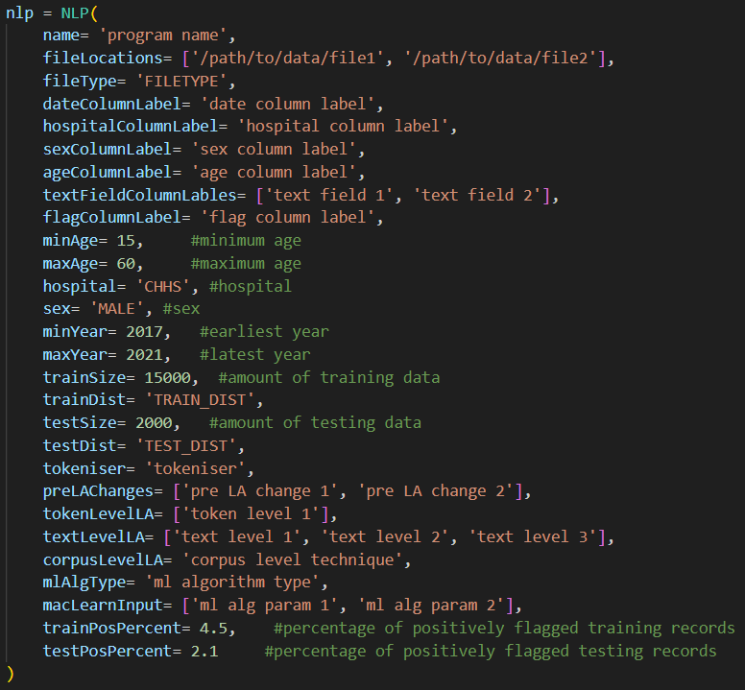
Each of the parameters in the constructor of an NLP object specifies an aspect of how to build an NLP program. Additionally, each parameter must adhere to a particular format, otherwise the code will produce an exception when run. The roles and formats of each parameter are specified in Appendix 2. Information about the different exceptions is detailed in Appendix 3. Once the NLP object is constructed, a program can be built according to the given specifications by running the create() method.
The create() method can take a considerable amount of time to run. Using a larger data set and more linguistic analysis techniques will cause the create() method to take longer to run. Whilst running, this method will print progress updates to the terminal.
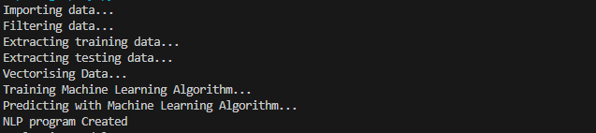
Once the create() method has run, the NLP program is built. A user can then evaluate, export, or operate the NLP program. To evaluate the NLP program, run the evaluateNLP() method followed by the viewEvaluation() method.
This will display a detailed evaluation of the program in the terminal.
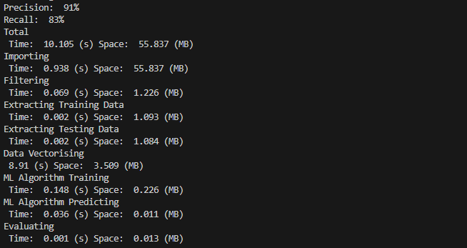
To export the NLP program, run the exportNLP() method.
This will pickle the NLP object into a new directory in EpiNLP Builder/model with a file called nlp.pkl contained within this directory. To approximate the time and space complexity of using the NLP program for annotation run the approximateComplexities() method followed by the viewEvaluation() method.
This will display the evaluation once again, with the approximated time and space complexities of the model.
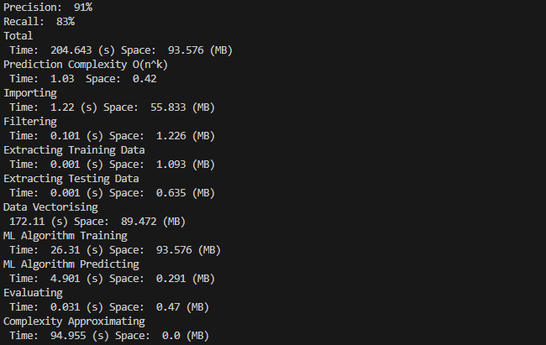
Finally, to review the input parameters for the NLP program, run the viewParameters() method.
This will display the program parameters in the terminal.
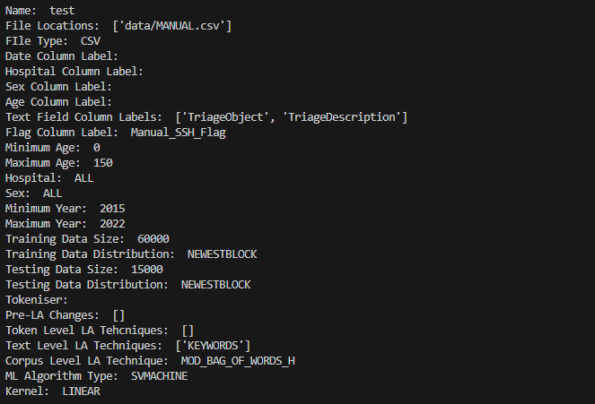

Using a Program
Once an NLP program has been created, it can be used to annotate an existing data set which contains free text. Given a .csv or .xlsx file containing wide-form data, where at least one of the columns contains free text, an NLP program can add a column to the end of this file containing classifications of the free text. This additional column will contain 0s and 1s corresponding to the annotations provided in the training data.
To implement this annotation process, there must be an NLP object which has run the create() method in the global scope. This can be achieved by following the above steps to build an NLP program and continuing in the same script or by importing a saved NLP program. Saved NLP programs can be imported using the Joblib library. Import the Joblib package with the line:
To import a saved NLP program, identify where it is stored within the model directory. If the program to be imported has name Program1, the NLP object will be stored at EpiNLP Builder/model/PROGRAM1-NLP-Program/nlp.pkl. This can be imported with the line:
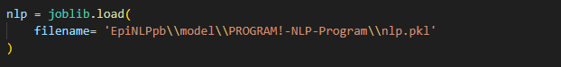
The filename parameter may need to be changed to an absolute path, depending on the current working directory. Now that there is an NLP object which has run the create() method in the global scope, the annotateDataCSV() method or annotateDataXLSX() method can be used to annotate a .csv or .xlsx file respectively. For .csv this will be:
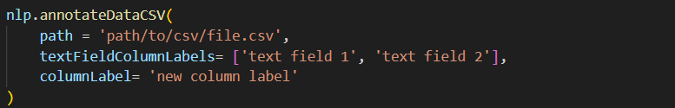
For .xlsx this will be:
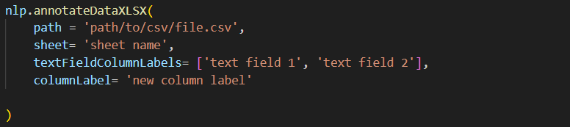

The path parameter is a string containing either the absolute path or the relative path from the current working directory of the existing file to be annotated. textFieldColumnLabels is a list of strings corresponding to the labels of the columns in the existing file, which contain the free text. This list must be the same length as the list used for the textFieldColumnLabels parameter in the constructor of the NLP object. The columnLabel parameter is a string containing the label for the new column to be added with the classifications. The sheet parameter in annotateDataXLSX() is a string containing the sheet name where the existing data is stored within the .xlsx file.
Running one of these methods will add a column of classifications to the file.

Graphical User Interface
EpiNLP Builder was designed to be used not only as a software package by developers, but also by non-technical users through a GUI. Currently, as of version 1.0, the GUI is not complete. This GUI will be completed in a subsequent version of EpiNLP Builder and these technical notes will be updated to include a detailed user guide for the GUI. The current source code for the GUI is included in the repository but is not yet suited for use.

Support
For further information regarding the structure, process, or usage of EpiNLP Builder there are a few sources which can be consulted. For support when using the software package directly, consult the package documentation available at:
...
To view the source code directly, the repository can be accessed on GitHub at:
...
Additionally, EpiNLP Builder is dependent on various open-source software packages. These dependencies are listed in Appendix 1 and are accompanied by a link to their respective documentations.
Finally, EpiNLP Builder continues development and maintenance within the ACT Health Epidemiology Section. To contact this team with a query about the software package please send an email to one of the following addresses:
George.mcnamara@act.gov.au or epicentre@act.gov.au

Appendices

Appendix 1: Dependencies

The following is a comprehensive list of Python packages utilised in the EpiNLP Builder package. For each package there is a link provided to the documentation.

abc: https://docs.python.org/3/library/abc.html

collections: https://docs.python.org/3/library/collections.html

Joblib: https://joblib.readthedocs.io/en/stable/

Matplotlib: https://matplotlib.org/stable/index.html

NLTK: https://www.nltk.org/

NumPy: https://numpy.org/doc/stable/

OpenPyXL: https://openpyxl.readthedocs.io/en/stable/

os: https://docs.python.org/3/library/os.html

pandas: https://pandas.pydata.org/docs/

PyQt6: https://doc.qt.io/qtforpython-6/

random: https://docs.python.org/3/library/random.html

SciPy: https://docs.scipy.org/doc/scipy/index.html

scikit-learn: https://scikit-learn.org/stable/index.html

sys: https://docs.python.org/3/library/sys.html

time: https://docs.python.org/3/library/time.html

tracemalloc: https://docs.python.org/3/library/tracemalloc.html

typing: https://docs.python.org/3/library/typing.html

unittest: https://docs.python.org/3/library/unittest.html

Appendix 2: NLP Parameter Roles/Formats
Listed below are the parameters used for constructing an NLP object, accompanied by a description of their role, and required format.
- name: The name of the NLP program to be built. When the file is exported it will be saved as model/name-NLP-Model/nlp.pkl. name must be a string which does not include any characters that cannot be included in file names on the user’s operating system.
- fileLocations: A list of paths of where the annotated data is stored in either .csv or .xlsx files. This list cannot be empty, and the paths must be formatted as ‘path/to/file.csv’. The paths must either be absolute or relative to the current working directory. All paths in fileLocations must end with the same file extension.
- fileType: The type of files the annotated data is stored in. Must be a string which is either ‘CSV’ or ‘XLSX’.
- dateColumnLabel: The label of the column in the annotated data which contains information related to the date associated with the text. If there is no such column in the data, then dateColumnLabel should be the empty string. dateColumnLabel must be a string. In the annotated data, dates must have the format ‘DD/MM/YYYY HH:MM:SS PM’.
- hospitalColumnLabel: The label of the column in the annotated data which contains information related to the hospital associated with the text. If there is no such column in the data, then hospitalColumnLabel should be the empty string. hospitalColumnLabel must be a string. In the annotated data, hospital can be either ‘CHHS’ for the Canberra Hospital or ‘CHPB’ for the Calvary Bruce Public Hospital, now called the North Canberra Hospital.
- sexColumnLabel: The label of the column in the annotated data which contains information related to the sex associated with the text. If there is no such column in the data, then sexColumnLabel should be the empty string. sexColumnLabel must be a string. In the annotated data, sex must be either 1 for male, 2 for female or 9 for other.
- ageColumnLabel: The label of the column in the annotated data which contains information related to the age associated with the text. If there is no such column in the data, then ageColumnLabel should be the empty string. ageColumnLabel must be a string. In the annotated data, age must be an integer.
- textFieldColumnLabels: The labels of the columns in the annotated data which contain the free text to be used for classification. textFieldColumnLabels must be a list of strings. textFieldColumnLabels cannot be an empty list or contain only the empty string.
- flagColumnLabels: The label of the column in the annotated data which contains the annotations. flagColumnLabels cannot be the empty string. In the annotated data, an annotating flag must be 0 or 1.
- minAge: The minimum age of persons whose records should be included in the training and testing data. Must be an integer between 0 and 150 (inclusive).
- maxAge: The maximum age of persons whose records should be included in the training and testing data. Must be an integer between minAge and 150 (inclusive).
- hospital: The hospital(s) from which to draw the data. Must be a string which is either ‘ALL’, ‘CHHS’ or ‘CHPB’.
- sex: The sex(es) of persons whose records should be included in the training and testing data. Must be a string which is either ‘ALL’, ‘MALE’ or ‘FEMALE’.
- minYear: The earliest year from which to draw data. Must be an integer between 2015 and 2022 (inclusive).
- maxYear: The latest year from which to draw data. Must be an integer between minYear and 2022 (inclusive).
- trainSize: The number of records to use in the training data. Must be an integer.
- trainDist: The distribution to use when extracting training records from the annotated data. Must be a string which is either ‘NEWESTBLOCK’, ‘RANDOMBLOCK’ or ‘UNIFORM’.
- testSize: The number of records to use in the testing data. Must be an integer. The sum of trainSize and testSize must be less than or equal to the number of records available in the training data which satisfy the demographic provided by the previous parameters.
- testDist: The distribution to use when extracting testing records from the annotated data. Must be a string which is either ‘NEWESTBLOCK’, ‘RANDOMBLOCK’ or ‘UNIFORM’.
- tokeniser: The name of the NLTK tokeniser to use for tokenising pieces of text. If a tokeniser is not needed, tokeniser should be the empty string. Otherwise, it must be a string which is either ‘WORD_TOKENISER’, ‘PUNC_TOKENISER’, or ‘TWEET_TOKENISER’.
- preLAChanges: A list of names of modifications to make to pieces of text before applying linguistic analysis techniques. If no modifications are to be made before linguistic analysis, preLAChanges should be the empty list, []. Otherwise, it must be a list of strings where the elements can be ‘REMOVE_STOPWORDS’ or ‘STEMMING’.
- tokenLevelLA: A list of names of token level linguistic analysis techniques to apply to the tokens in a piece of text. If no token level techniques are to be used, tokenLevelLA should be the empty list, []. Otherwise, it must be [‘POS_TAG’]. If tokeniser is the empty string then tokenLevelLA must be the empty list.
- textLevelLA: A list of names of text level linguistic analysis techniques to apply to a piece of text. If no text level techniques are to be used, textLevelLA should be the empty list, []. Otherwise, it must be a list of strings where elements can be ‘KEYWORDS’ or ‘ASCII_CONVERSION’.
- corpusLevelLA: The name of the corpus level technique to be applied to the training pieces of text. If no corpus level technique is to be used, corpusLevelLA should be the empty string. Otherwise, it must be a string which is either:
'BAG_OF_WORDS_C', 'MOD_BAG_OF_WORDS_C', 'BAG_OF_WORDS_F', 'MOD_BAG_OF_WORDS_F', 'BAG_OF_WORDS_H' or 'MOD_BAG_OF_WORDS_H'
For the NLP object to be constructed there must be at least one linguistic analysis technique. So having tokenLevelLA as [], textLevelLA as [], and corpusLevelLA as ‘’ will produce an error.
- mlAlgType: The name of the type of Sci-Kit Learn machine learning algorithm to be used. Must be a string which is either ‘DECISIONTREE’ or ‘SVMACHINE’.
- macLearnInput: A list of additional parameters for the machine learning algorithm which will differ depending on the choice of algorithm. If mlAlgType is ‘DECISIONTREE’ then macLearnInput will specify the impurity measure to use in the Decision Tree algorithm.
In this case, macLearnInput must be [‘GINI’], [‘ENTROPOY’] or [‘LOGLOSS’]. If mlAlgType is ‘SVMACHINE’ then macLearnInput will specify the kernel to use in the Support Vector Machine algorithm.
In this case, macLearnInput must be [‘LINEAR’], [‘RBF’, gamma], [‘POLYNOMIAL’, degree, r] or [‘SIGMOID’, gamma, r]. gamma is a float greater than 0, degree is an integer and r is a float.
- trainPosPercent: The desired percentage of pieces of text in the training data which are annotated with a 1. If this percentage is not to be specified, then trainPosPercent should be –1. Otherwise, it should be a float between 0 and 100 (exclusive).
- testPosPercent: The desired percentage of pieces of text in the testing data which are annotated with a 1. If this percentage is not to be specified, then testPosPercent should be –1. Otherwise, it should be a float between 0 and 100 (exclusive).

Appendix 3: Exceptions
Listed below are the custom exceptions defined in EpiNLP Builder, accompanied by the cause of each exception (ordered as they are defined in the source code):
- InsufficientMeasureListException: Raised when measureList does not provide enough records to approximate complexity.
- EmptyActualFlagsException: Raised when actualFlags is empty.
- EmptyPredictedFlagsException: Raised when predictFlags is empty.
- FlagsNotEqualException: Raised when the lengths of actualFlags and predictedFlags are not equal.
- BadActualFlagException: Raised when an element of actualFlags is not 0 or 1.
- BadPredictedFlagException: Raised when an element of predictedFlags is not 0 or 1.
- TimesSpacesNotEqualException: Raised when the sizes of times and spaces are not equal.
- MoreDataThanRecordsException: Raised when trying to extract more data than there are records available.
- UnsupportedFileTypeException: Raised when fileType is not in SUPPORTED_FILE_TYPES.
- MinAgeException: Raised when minAge is less than 0.
- MaxAgeException: Raised when maxAge is less than minAge or greater than 150.
- HospitalException: Raised when the hospital input is invalid.
- SexException: Raised when the sex input is invalid.
- MinYearException: Raised when minYear is out of range.
- MaxYearException: Raised when maxYear is out of range.
- MinMaxYearException: Raised when maxYear is less than minYear.
- TrainDistException: Raised when the input training distribution is invalid.
- TestDistException: Raised when the input testing distribution is invalid.
- TrainPosPercentException: Raised when the percentage of positively flagged training records is less than or equal to 0 or greater than or equal to 100.
- TestPosPercentException: Raised when the percentage of positively flagged testing records is less than or equal to 0 or greater than or equal to 100.
- MLAlgTypeException: Raised when the input mlAlgType is invalid.
- ImpurityException: Raised when the impurity measure in macLearnInput is invalid.
- KernelException: Raised when the kernel in macLearnInput is invalid.
- NoRBFGammaException: Raised when no gamma parameter is provided in macLearnInput for an RBF kernel.
- NegRBFGammaException: Raised when the gamma parameter provided in macLearnInput for an RBF kernel is non-positive.
- NoPolynomialParameterException: Raised when no degree or r parameter is provided in macLearnInput for a polynomial kernel.
- NegPolynomialDegreeException: Raised when the degree parameter provided in macLearnInput for a polynomial kernel is non-positive.
- NoSigmoidParameterException: Raised when no gamma or r parameter is provided in macLearnInput for a sigmoid kernel.
- NegSigmoidGammaException: Raised when the gamma parameter provided in macLearnInput for a sigmoid kernel is non-positive.
- EmptyFlagsVectorsException: Raised when trainVectors, trainFlags, or testVectors is empty.
- TrainVectorsFlagsNotEqualException: Raised when the number of training vectors and flags are not equal.
- VectorsNotEqualException: Raised when the lengths of testing and training vectors are not equal.
- NoLATechniquesException: Raised when no token, text or corpus level LA techniques are provided.
- NoTokeniserException: Raised when token level techniques are provided with no tokeniser.
- TokeniserException: Raised when the input tokeniser is invalid.
- PreLAException: Raised when the input pre-LA changes are invalid.
- TokenLevelException: Raised when the input token level techniques are invalid.
- TextLevelException: Raised when the input text level techniques are invalid.
- CorpusLevelException: Raised when the input corpus level technique is invalid.
- NegTrainSizeException: Raised when train size is less than 0.
- NegTestSizeException: Raised when test size is less than 0.
- NoTextFieldsException: Raised when no text field column labels are provided.
- NoFlagFieldException: Raised when no flag column label is provided.
- ColumnLabelException: Raised when one of the column labels cannot be found in the data file.
- NameExistsException: Raised when trying to export an NLP program and there is already a program stored with the same name.
- NotEnoughClassesException: Raised when trainedModel.fit() raises "ValueError: The number of classes has to be greater than one; got 1 class".
- TreeGraphException: Raised when trying to plot a tree graph for a SVM algorithm.

Appendix 4: Vectorisation Techniques
Detailed below are the methodologies for each of the pre-linguistic changes, token level techniques, text level techniques, and corpus level techniques.
Pre-Linguistic Changes:
- REMOVE_STOPWORDS: This change is implemented by the method stopwordRemoval() defined in package/vectorise/nltkvectorise.py. This method converts a piece of text into a list of tokens using NLTK’s word tokeniser. It then removes any tokens form the list which are elements of NLTK’s stopwords list. Finally, it combines the remaining tokens back into a single string.
- STEMMING: This change is implemented by the method stemming() defined in package/vectorise/nltkvectorise.py. This method converts a piece of text into a list of tokens using NLTK’s word tokeniser. It then uses NLTK’s SnowballStemmer to convert each token into its root form. Finally, it combines the remaining tokens back into a single string.
Token Level Techniques:
- POS_TAG: This technique is implemented by the method posTag() defined in package/vectorise/nltkvectorise.py. This method uses NLTK’s part of speech tagger to convert a list of tokens into a list of parts of speech. These parts of speech are then replaced by their index in the UNIVERSAL_TAGS dictionary defined in package/vectorise/constants.py. This creates a numerical vector. The value –2 is then appended to this vector repeatedly until it is of length MAX_TOKENS, defined in package/vectorise/constants.py.
Text Level Techniques:
- KEYWORDS: This technique is implemented by the method keywordCheck() defined in package/vectorise/base.py. This method determines if each word or word pair contained in KEYWORDS, defined in package/vectorise/constants.py, is contained in a piece of text. It then produces a list of 0s and 1s corresponding to the presence of each element in KEYWORDS.
- ASCII_CONVERSION: This technique is implemented by the method asciiConversion() defined in package/vectorise/base.py. This method converts an input piece of text into a list of characters. It then uses the Python function ord() to convert each character into its Unicode code point. This produces a list of integers. The value –1 is then appended to this list repeatedly until it is of length MAX_CHARS defined in package/vectorise/constants.py.
Corpus Level Techniques:
All the corpus level techniques leverage the function bagOfWords() defined in package/vectorise/nltkvectorise.py. The key parameters of this function are trainRecords, testRecords, vect, and mod. trainRecords and testRecords are lists of strings taken from the annotated data. These are combined to form a list of strings called corpus. The parameter mod is a Boolean. If it is TRUE, then the method prepareTexts() is applied to corpus which removes the stopwords from and stems each string in corpus.
bagOfWords() then creates the local variable vectoriser which is an NLTK CountVectorizer, TfidfVectorizer, or HashingVectorizer if vect is ‘COUNT’, ‘FREQ’, or ‘HASH’ respectively. The vectoriser method fit_transform() is then called with corpus as its input parameter. This method stores the vocabulary generated by corpus in the vectoriser and outputs the vectorised pieces of text. These vectors are separated into training and testing data and returned by bagOfWords().
- BAG_OF_WORDS_C: This technique is implemented by the method bagOfWordsC() defined in package/vectorise/nltkvectorise.py. bagOfWordsC() calls the bagOfWords() function with vect=’COUNT’ and mod=FALSE.
- MOD_BAG_OF_WORDS_C: This technique is implemented by the method modBagOfWordsC() defined in package/vectorise/nltkvectorise.py. modBagOfWordsC() calls the bagOfWords() function with vect=’COUNT’ and mod=TRUE.
- BAG_OF_WORDS_F: This technique is implemented by the method bagOfWordsF() defined in package/vectorise/nltkvectorise.py. bagOfWordsF() calls the bagOfWords() function with vect=’FREQ’ and mod=FALSE.
- MOD_BAG_OF_WORDS_F: This technique is implemented by the method modBagOfWordsF() defined in package/vectorise/nltkvectorise.py. modBagOfWordsF() calls the bagOfWords() function with vect=’FREQ’ and mod=TRUE.
- BAG_OF_WORDS_H: This technique is implemented by the method bagOfWordsH() defined in package/vectorise/nltkvectorise.py. bagOfWordsH() calls the bagOfWords() function with vect=’HASH’ and mod=FALSE.
- MOD_BAG_OF_WORDS_H: This technique is implemented by the method modBagOfWordsH() defined in package/vectorise/nltkvectorise.py. modBagOfWordsH() calls the bagOfWords() function with vect=’HASH’ and mod=TRUE.

Bibliography
- BM. What is Natural Language Processing? [Internet]. IBM. 2023. Available from: https://www.ibm.com/topics/natural-language-processing
- Smirnov M (Misha). Common metrics for evaluating natural language processing (NLP) models [Internet]. Medium. 2022. Available from: https://medium.com/@mikeusru/common-metrics-for-evaluating-natural-language-processing-nlp-models-e84190063b5f
- Doxygen: Main Page [Internet]. www.doxygen.nl. Available from: https://www.doxygen.nl/index.html
- SmartDraw is the Best Way to Make a Diagram [Internet]. www.smartdraw.com. Available from: https://app.smartdraw.com/
Acknowledgment of Country
We acknowledge the Ngunnawal people as traditional custodians of the ACT and recognise any other people or families with connection to the lands of the ACT and region. We acknowledge and respect their continuing culture and the contribution they make to the life of this city and this region.

Accessibility
If you have difficulty reading a standard printed document and would like an alternative format, please phone 13 22 81.

If English is not your first language and you need the Translating and Interpreting Service (TIS),
please call 13 14 50.
For further accessibility information, visit: www.health.act.gov.au/accessibility
www.health.act.gov.au | Phone: 132281
© Australian Capital Territory, Canberra Month Year

